[CURRICULUM VITAE](https://www.google.co.in/search?q=curriculum+vitae&biw=1517&bih=704&noj=1&tbm=isch&tbo=u&source=univ&sa=X&ei=7B_0VMnCI8SNuATIooC4CA&sqi=2&ved=0CDIQsAQ)

**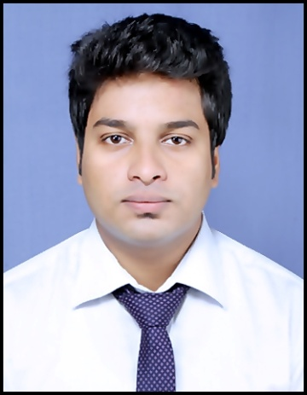TAPAS KUMAR BHOWMICK**

**Permanent Address:** 58/4, Vivek Nagar  
 P.O.- Titagarh , P.S.- Khardaha  
 Kolkata – 700119

**Contact Number:** +919073375283

**E-mail :** tapas.k.bhowmick90@gmail.com

**Personal Profile:**

To pursue highly challenging ventures where I can contribute to the organizational goals there by simultaneously acquire new technical skills, contribute constructively and with the fullest utilization of my institutional technical experience and educational background to match the organization’s growth and strength.

**Academic Profile:**

* Graduate in **B.PHARM**  From **GURUNANANK INSTITUTE OF PHARMACEUTICAL SCIENCE AND TECHNOLOGY** under **WEST BENGAL UNIVERSITY OF TECHNOLOGY (M.A.K.A.U.T)**

|  |  |  |  |  |  |
| --- | --- | --- | --- | --- | --- |
| **YEAR** | **UNIVERSITY** | **YEAR OF PASSING** | **SGPA(ODD SEM)** | **SGPA(EVEN SEM)** | **YGPA** |
| 1st | WBUT | 2012 | 7.25 | 6.62 | 6.91 |
| 2nd | WBUT | 2013 | 7.91 | 7.64 | 7.79 |
| 3rd | WBUT | 2014 | 7.75 | 8.55 | 8.18 |
| 4th | WBUT | 2015 | 8.26 | 9.15 | 8.64 |

|  |  |
| --- | --- |
| **DGPA** | 7.99 |

* Passed **HIGHER SECONDARY EXAMINATION** from **BARRACKPORE GOVERNMENT HIGH SCHOOL, under WEST BENGAL COUNCIL OF HIGHER SECONDARY EDUCATION.**

|  |  |  |  |  |
| --- | --- | --- | --- | --- |
| **EXAMINATION** | **BOARD** | **YEAR OF PASSING** | **MARKS (%)** | **DIV** |
| HIGHER SECONDARY | WBCHSE | 2010 | 70.2% | 1st |

* Passed **SECONDARY EXAMINATION**  from **BARRACKPORE GOVERNMENT HIGH SCHOOL, under WEST BENGAL BOARD OF SECONDARY EDUCATION.**

|  |  |  |  |  |
| --- | --- | --- | --- | --- |
| **EXAMINATION** | **BOARD** | **YEAR OF PASSING** | **MARKS (%)** | **DIV** |
| SECONDARY | WBBSE | 2008 | 76% | 1st |

**Professional Training:**

**B. Pharm 3rdyr Practical experience in CAPLET INDIA PRIVATE LIMITED, Rekjuani, Rajarhat, KOLKATA-700135, from 7th July,2014 to 12th July,2014, total duration were 6 days.**

**Project Details:**

**B.PHARM PROJECT:** “**A REVIEW ON IN-VITRO ANTI INFLAMMATORY ACTIVITIES OF SOME PLANTS FROM RUBIACEAE AND FABACEAE FAMILY FOUND IN BENGAL**”

**Other Details:**

* Completed  **Diploma** in **“Painting”** from **“BHARATIYA CHARU KALA MANDIR”**

|  |  |
| --- | --- |
| **LANGUAGES KNOWN:** | English, Hindi, Bengali |
| **BASIC COMPUTER SKILL:** | Knowledge of MS WORD, EXCEL, POWER POINT,C & C++. |

**Personal Details:**

**Father’s Name:** Nikhil Chandra Bhowmick.

**D.O.B.** : 10.10.1990

**Nationality:** INDIAN

**Religion:** HINDUISM

**Marital Status:** SINGLE

**Hobbies:** interested in painting, playing drums, reading story books , computing, event management.

**Declaration:**

|  |
| --- |
| IMG_20160726_001619.jpg I, Tapas Kumar Bhowmick hereby declare that the above mentioned information is correct up to my knowledge and I bear responsibility for the correctness of the above mentioned particulars.  Date- 25.07.2016  (Tapas Kumar Bhowmick)  Place : Kolkata. ( Signature) |